**CHEETAH**

Turn on the Digital Lynx SX box.

Start Cheetah 6.4.2 with desktop icon.

Choose a Config file. The options can be accessed via desktop icon. Or at C:\Program **Files\Neuralynx\Cheetah5\Configuration\JJS configs\Neuronexus configs**

For example, A4by2tetConfigwEncoder DAQ1 w double wheel 2kHz laser events revised.cfg

For the LFP CSCs, Sub Sampling Interleave should be 16, making the sampling rate 2000kHz.

Low Cut = 0.1Hz. High Cut = 500Hz. Enable “Input Inverted”, “Acquisition Entity Processing”, & “Write Records to File” (D:\CheetahData\todays date

LFP channels will not be used for analysis. They will be saved in the database session folder, but removed on my pc.

The display order for the CSCs and their corresponding AD channels is as follows:

|  |  |  |  |  |  |  |  |  |  |  |
| --- | --- | --- | --- | --- | --- | --- | --- | --- | --- | --- |
| CSC1 – 26 | CSC5 – 11 | CSC10 – 31 | CSC22 – 1 | CSC25 – 17 | CSC29 – 19 |  |  |  |  |  |
| CSC3 – 10 | CSC7 – 12 | CSC12 – 15 | CSC24 – 2 | CSC27 – 18 | CSC31 – 20 |  |  |  |  |  |
| CSC6 – 29 | CSC9 – 13 | CSC13 – 9 | CSC18 – 22 | CSC30 – 5 | CSC33 – 32 |  |  |  |  |  |
| CSC8 – 30 | CSC11 – 14 | CSC15 – 25 | CSC20 – 6 | CSC32 – 21 | CSC34 – 33 |  |  |  |  |  |
| CSC2 – 27 | CSC14 – 8 | CSC17 – 23 | CSC21 – 0 | CSC26 – 3 | CSC35 – 34 |  |  |  |  |  |
| CSC4 – 28 | CSC16 – 24 | CSC19 – 7 | CSC23 – 16 | CSC28 – 4 | CSC36 – 35 |  |  |  |  |  |

CSC33-CSC36 are on the second headstage input port on the Lynx box. These wires come from the rig and are patched into the breakout board on port2.

CSC33 = platform rotary encoder

CSC34 = wheel rotary encoder channel 1 (quadrature)

CSC35 = wheel rotary encoder channel 2 (quadrature)

CSC36 = analog signal from the Teensy with the online estimate of wheel speed. *This has not worked for a long time.

Can be ignored.

For CSC33-CSC36, there should be not Low Cut filter. High Cut filter at 500Hz. **Reference = Source 02 Panel Ground**

Arrange the settings in Cheetah as you see fit.

I have only ever consistently recorded with one camera, the infrared (IR) camera that faces the mouse’s LEFT eye. In the cheetah Video Settings, this should read as

Capture Device: Basler acA1300-75gm

Hardware ID: 23287098

Input Type: GigE

Video Format: NTSC

Format Resolution: 640 x 480

Frame Rate: 50fps

Brightness = 4. Gamma = 64. Gain = 0.

**AUDIO**

Matlab code folder for brainstem recordings: C:\Users\admin\Documents\MATLAB

Before starting the experiment, run the shortcut “PulsePal and More.” That will run the script below:

p1 = genpath('C:\PulsePal_MATLAB');

addpath(p1);

disp('PulsePal added')

addpath(genpath('C:\Users\admin\Documents\MATLAB\Matlab_Add_Ons\code_by_Jeff'))

disp('Jeff code add ons added')

addpath(genpath('C:\Users\admin\Documents\MATLAB\NlxFFT\MFiles\NetCom\Matlab_M-files'))

disp('Nlx command functions added')

This will add the PulsePal code, the custom code for playing audio during the experiment, and the netcom M-files from Neuralynx for recording timestamps, etc.

Execute

(1) InitializeAudio.m - this will go to the right folder with the sound file, read the wav file, initialize, and play the sound once

(2) ShutterSequence.m

This function will execute playShutterSoundScript_PTB five times with 3 second delays between “trials”

*Do not need [[y, Fs, p, t] = prepareShutterSound()]- outdated*

Events will display as TTL = 128, Event ID = 666, Event String = ‘ShutterSoundOn’

The Event corresponds to the start of the sound file, beginning with the first “click” sound. There are two clicks, about 1 second apart, because the sound file is a recording of the laser shutter opening and closing with 1 second latency.

The sound file is 'SingleShutterClick_short.wav'

The mock shutter sound events are pseudorandomly added by the experimenter during the session. I usually alternate a couple times between laser stim and shutter sound in the intervals between when I am actively turning the platform.

Before beginning the recording session, test out the sound levels on the computer with the mock shutter clicks and make sure that they are the right loudness. They should be just as loud as the click from the actual laser shutter.

**LASER**

For more complicated laser stim sequences, there is a function with some code form Manish in the folder

C:\Users\admin\Desktop\JJS\matlab code The function is NPH_phaseStim_varSTIM.m

It uses functions from PulsePal to generate the sequence.

Make sure that the end of the laser patch cord is not facing away from you or has a stopper on the end so that the light doesn’t shine toward you. Turn on the power supply to the laser (PSU-III-LED). It will make a bunch of gnarly sounds, kind of like an engine revving and switching gears. The power supply must be getting old. The sounds will go on for a long time but should eventually stop, and be replaced by a quiet hum. Turn the power knob to a low value, like 3mW.

When the ferrule is pointing in a safe direction, turn the key from “Off” to “On” to send light through the laser. Light will now be exciting the laser. It may be blocked by the shutter, depending on the state of the shutter driver (Uniblitz Model VCM-D1). For the shutter driver, the key should be turned toward “STD”. Set the right toggle switch to “Remote” (for computer control). Set the left toggle switch to “N.C.” to allow light through the ferrule to see if the laser light is visible. There should be solid green lights under “Driver” and “Sync.” Once this is confirmed, set that toggle switch to “N.O” and try to operate the shutter through PulsePal. The PulsePal (v2.0) hardware unit should be connected via BNC cables to the Shutter driver on one end and to the green breakout board (BRK2X17) on the other end (which, in turn, is connected to TTL I/O Ports 1 & 2 and the Lynx box by a grey ribbon cable).

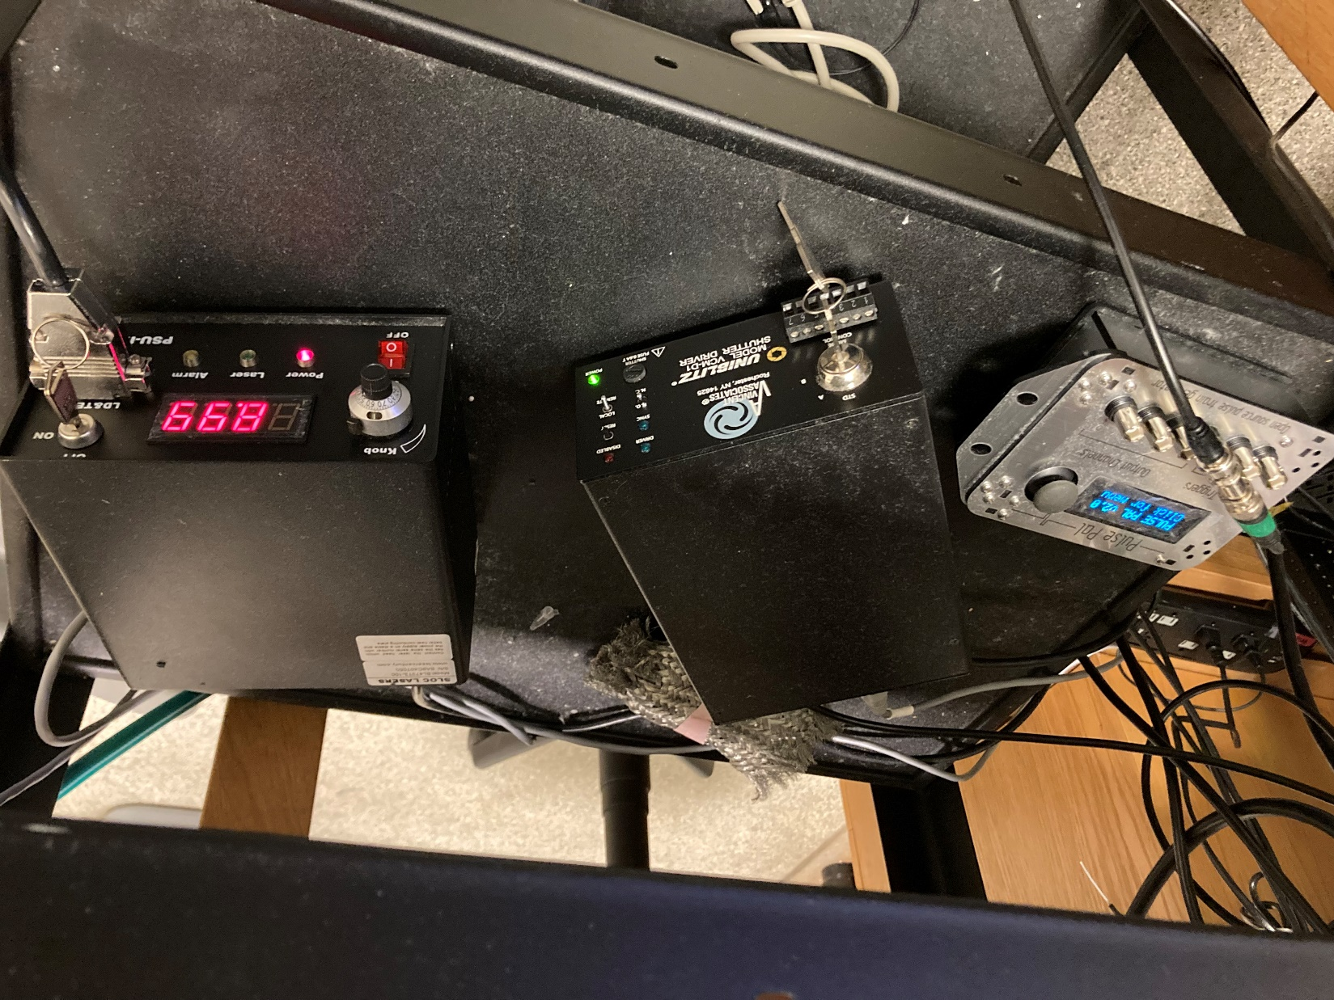

Type the command >> PulsePal in matlab. Matlab should read

>> PulsePal

Searching for Pulse Pal. Please wait.

Connecting with PsychToolbox serial interface (low latency).

Trying port COM6

Pulse Pal connected on port COM6

Next, type >> PulsePalGUI

The Pulse Pal Program Editor window should appear, with default settings.

Set Soft-triggered channels to “1”. Set “Phase 1 Duration” to “1”. Set “Pulse Interval” to “3”. Set “Train” to “20”.

Click the little box-with-arrow symbol next to the Save button to update the settings in PulsePal. Try out a pulse train by clicking on the large lightning bolt symbol. It should repeat an “ON” / “OFF” pair of shutter sounds (1 second between ON and OFF) five times, with three second intervals between each sound.

Check that the events are being displayed in Cheetah.

The ON click of the shutter should read TTL = 4, Event ID = 11,

Event String = TTL_Input on AcqSystem 1_0 board 0 port 2 value (0x0004)

The OFF click of the shutter should read TTL = 0, Event ID = 11,

Event String = TTL_Input on AcqSystem 1_0 board 0 port 2 value (0x0000)

For some earlier sessions with a different configuration, the laser on events had an Event String = “Laser On”

